Alexander Cannell

CSIA 6210

﻿Week 4: OSINT

**Whois: I determined that happypacket.net is protected by Cloudflare which is a internet security company, and whois guard which a domain owners information protection service. It was very hard to get around both Cloudflare and whois guard.**

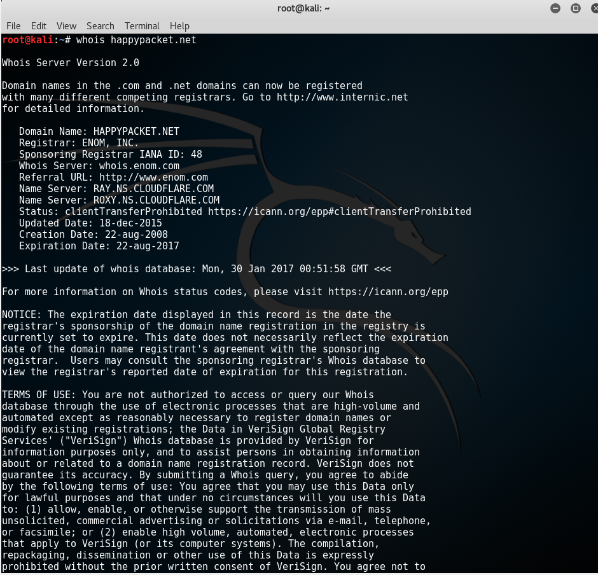

**root@kali**:**~**# whois happypacket.net  
  
Whois Server Version 2.0  
  
Domain names in the .com and .net domains can now be registered  
with many different competing registrars. Go to http://www.internic.net  
for detailed information.  
  
 Domain Name: HAPPYPACKET.NET  
 Registrar: ENOM, INC.  
 Sponsoring Registrar IANA ID: 48  
 Whois Server: whois.enom.com  
 Referral URL: http://www.enom.com  
 Name Server: RAY.NS.CLOUDFLARE.COM  
 Name Server: ROXY.NS.CLOUDFLARE.COM  
 Status: clientTransferProhibited https://icann.org/epp#clientTransferProhibited  
 Updated Date: 18-dec-2015  
 Creation Date: 22-aug-2008  
 Expiration Date: 22-aug-2017  
  
>>> Last update of whois database: Mon, 30 Jan 2017 00:50:58 GMT <<<  
  
  
  
Domain Name: HAPPYPACKET.NET  
Registry Domain ID: 1515580022_DOMAIN_NET-VRSN  
Registrar WHOIS Server: whois.enom.com  
Registrar URL: www.enom.com  
Updated Date: 2014-08-07T06:12:16.00Z  
Creation Date: 2008-08-22T06:05:00.00Z  
Registrar Registration Expiration Date: 2017-08-22T06:05:14.00Z  
Registrar: ENOM, INC.  
Registrar IANA ID: 48  
Reseller: NAMECHEAP.COM  
Domain Status: clientTransferProhibited https://www.icann.org/epp#clientTransferProhibited  
Registry Registrant ID:   
Registrant Name: WHOISGUARD PROTECTED  
Registrant Organization: WHOISGUARD, INC.  
Registrant Street: P.O. BOX 0823-03411  
Registrant City: PANAMA  
Registrant State/Province: PANAMA  
Registrant Postal Code: 00000  
Registrant Country: PA  
Registrant Phone: +507.8365503  
Registrant Phone Ext:   
Registrant Fax: +51.17057182  
Registrant Fax Ext:  
Registrant Email: 197A35971C3D48F790F63429093D6781.PROTECT@WHOISGUARD.COM  
Registry Admin ID:   
Admin Name: WHOISGUARD PROTECTED  
Admin Organization: WHOISGUARD, INC.  
Admin Street: P.O. BOX 0823-03411  
Admin City: PANAMA  
Admin State/Province: PANAMA  
Admin Postal Code: 00000  
Admin Country: PA  
Admin Phone: +507.8365503  
Admin Phone Ext:   
Admin Fax: +51.17057182  
Admin Fax Ext:  
Admin Email: 197A35971C3D48F790F63429093D6781.PROTECT@WHOISGUARD.COM  
Registry Tech ID:   
Tech Name: WHOISGUARD PROTECTED  
Tech Organization: WHOISGUARD, INC.  
Tech Street: P.O. BOX 0823-03411  
Tech City: PANAMA  
Tech State/Province: PANAMA  
Tech Postal Code: 00000  
Tech Country: PA  
Tech Phone: +507.8365503  
Tech Phone Ext:   
Tech Fax: +51.17057182  
Tech Fax Ext:   
Tech Email: 197A35971C3D48F790F63429093D6781.PROTECT@WHOISGUARD.COM  
Name Server: RAY.NS.CLOUDFLARE.COM  
Name Server: ROXY.NS.CLOUDFLARE.COM  
DNSSEC: unSigned  
Registrar Abuse Contact Email: abuse@enom.com  
Registrar Abuse Contact Phone: +1.4252982646  
URL of the ICANN WHOIS Data Problem Reporting System: http://wdprs.internic.net/  
>>> Last update of WHOIS database: 2014-08-07T06:12:16.00Z <<<

**Host:**

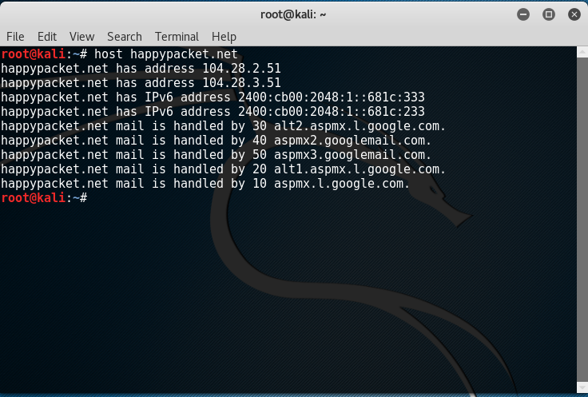

﻿

**root@kali**:**~**# host happypacket.net  
happypacket.net has address 104.28.2.51  
happypacket.net has address 104.28.3.51  
happypacket.net has IPv6 address 2400:cb00:2048:1::681c:333  
happypacket.net has IPv6 address 2400:cb00:2048:1::681c:233  
happypacket.net mail is handled by 30 alt2.aspmx.l.google.com.  
happypacket.net mail is handled by 40 aspmx2.googlemail.com.  
happypacket.net mail is handled by 50 aspmx3.googlemail.com.  
happypacket.net mail is handled by 20 alt1.aspmx.l.google.com.  
happypacket.net mail is handled by 10 aspmx.l.google.com.

**ARIN**:﻿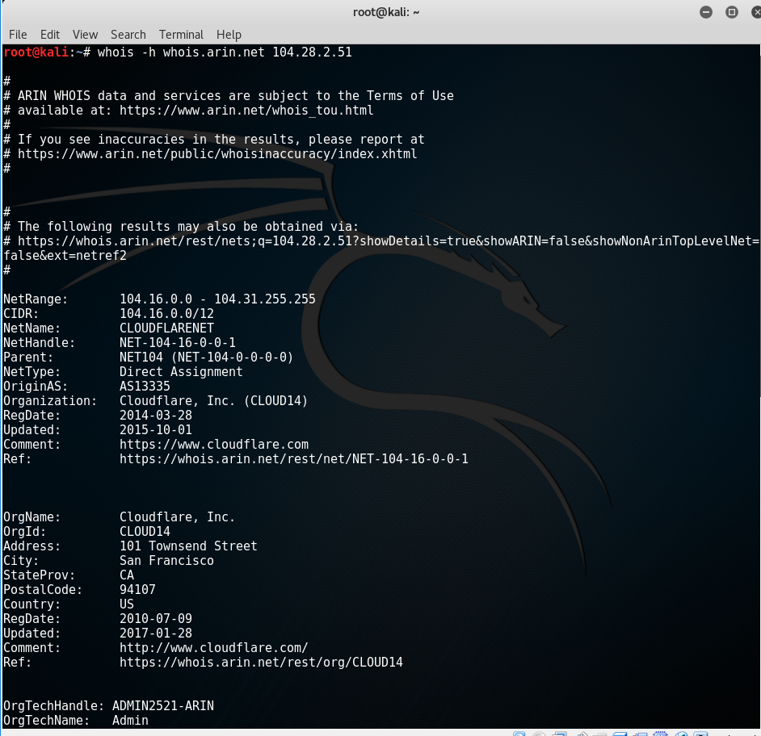

**root@kali**:**~**# whois -h whois.arin.net 104.28.2.51  
  
#  
# ARIN WHOIS data and services are subject to the Terms of Use  
# available at: https://www.arin.net/whois_tou.html  
#  
# If you see inaccuracies in the results, please report at  
# https://www.arin.net/public/whoisinaccuracy/index.xhtml  
#  
  
  
#  
# The following results may also be obtained via:  
# https://whois.arin.net/rest/nets;q=104.28.2.51?showDetails=true&showARIN=false&showNonArinTopLevelNet=false&ext=netref2  
#  
  
NetRange: 104.16.0.0 - 104.31.255.255  
CIDR: 104.16.0.0/12  
NetName: CLOUDFLARENET  
NetHandle: NET-104-16-0-0-1  
Parent: NET104 (NET-104-0-0-0-0)  
NetType: Direct Assignment  
OriginAS: AS13335  
Organization: Cloudflare, Inc. (CLOUD14)  
RegDate: 2014-03-28  
Updated: 2015-10-01  
Comment: https://www.cloudflare.com  
Ref: https://whois.arin.net/rest/net/NET-104-16-0-0-1  
  
  
  
OrgName: Cloudflare, Inc.  
OrgId: CLOUD14  
Address: 101 Townsend Street  
City: San Francisco  
StateProv: CA  
PostalCode: 94107  
Country: US  
RegDate: 2010-07-09  
Updated: 2017-01-28  
Comment: http://www.cloudflare.com/  
Ref: https://whois.arin.net/rest/org/CLOUD14  
  
  
OrgTechHandle: ADMIN2521-ARIN  
OrgTechName: Admin  
OrgTechPhone: +1-650-319-8930   
OrgTechEmail: admin@cloudflare.com  
OrgTechRef: https://whois.arin.net/rest/poc/ADMIN2521-ARIN  
  
OrgNOCHandle: NOC11962-ARIN  
OrgNOCName: NOC  
OrgNOCPhone: +1-650-319-8930   
OrgNOCEmail: noc@cloudflare.com  
OrgNOCRef: https://whois.arin.net/rest/poc/NOC11962-ARIN  
  
OrgAbuseHandle: ABUSE2916-ARIN  
OrgAbuseName: Abuse  
OrgAbusePhone: +1-650-319-8930   
OrgAbuseEmail: abuse@cloudflare.com  
OrgAbuseRef: https://whois.arin.net/rest/poc/ABUSE2916-ARIN  
  
RNOCHandle: NOC11962-ARIN  
RNOCName: NOC  
RNOCPhone: +1-650-319-8930   
RNOCEmail: noc@cloudflare.com  
RNOCRef: https://whois.arin.net/rest/poc/NOC11962-ARIN  
  
RAbuseHandle: ABUSE2916-ARIN  
RAbuseName: Abuse  
RAbusePhone: +1-650-319-8930   
RAbuseEmail: abuse@cloudflare.com  
RAbuseRef: https://whois.arin.net/rest/poc/ABUSE2916-ARIN  
  
RTechHandle: ADMIN2521-ARIN  
RTechName: Admin  
RTechPhone: +1-650-319-8930   
RTechEmail: admin@cloudflare.com  
RTechRef: https://whois.arin.net/rest/poc/ADMIN2521-ARIN  
  
  
#  
# ARIN WHOIS data and services are subject to the Terms of Use  
# available at: https://www.arin.net/whois_tou.html  
#  
# If you see inaccuracies in the results, please report at  
# https://www.arin.net/public/whoisinaccuracy/index.xhtml  
#  
  
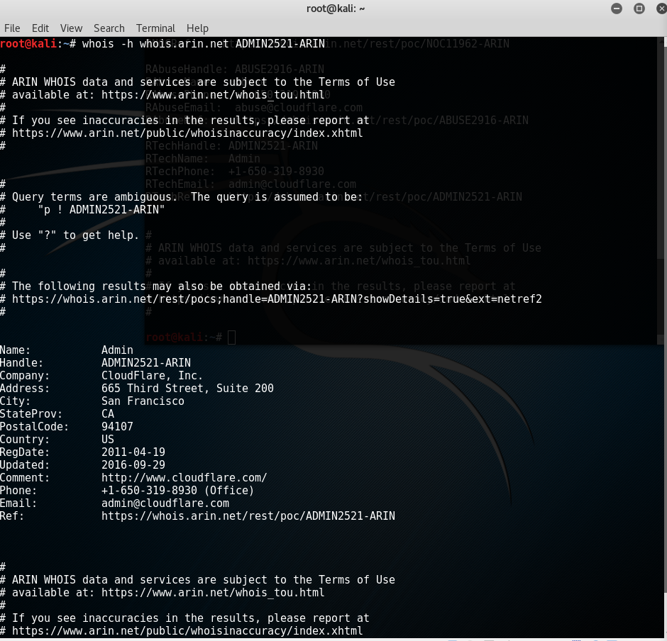

﻿

**root@kali**:**~**# whois -h whois.arin.net ADMIN2521-ARIN  
  
#  
# ARIN WHOIS data and services are subject to the Terms of Use  
# available at: https://www.arin.net/whois_tou.html  
#  
# If you see inaccuracies in the results, please report at  
# https://www.arin.net/public/whoisinaccuracy/index.xhtml  
#  
  
  
#  
# Query terms are ambiguous. The query is assumed to be:  
# "p ! ADMIN2521-ARIN"  
#  
# Use "?" to get help.  
#  
  
#  
# The following results may also be obtained via:  
# https://whois.arin.net/rest/pocs;handle=ADMIN2521-ARIN?showDetails=true&ext=netref2  
#  
  
  
Name: Admin  
Handle: ADMIN2521-ARIN  
Company: CloudFlare, Inc.  
Address: 665 Third Street, Suite 200  
City: San Francisco  
StateProv: CA  
PostalCode: 94107  
Country: US  
RegDate: 2011-04-19  
Updated: 2016-09-29  
Comment: http://www.cloudflare.com/  
Phone: +1-650-319-8930 (Office)  
Email: admin@cloudflare.com  
Ref: https://whois.arin.net/rest/poc/ADMIN2521-ARIN  
  
  
  
#  
# ARIN WHOIS data and services are subject to the Terms of Use  
# available at: https://www.arin.net/whois_tou.html  
#  
# If you see inaccuracies in the results, please report at  
# https://www.arin.net/public/whoisinaccuracy/index.xhtml  
#

﻿

**root@kali**:**~**# whois -h whois.arin.net NOC11962-ARIN  
  
#  
# ARIN WHOIS data and services are subject to the Terms of Use  
# available at: https://www.arin.net/whois_tou.html  
#  
# If you see inaccuracies in the results, please report at  
# https://www.arin.net/public/whoisinaccuracy/index.xhtml  
#

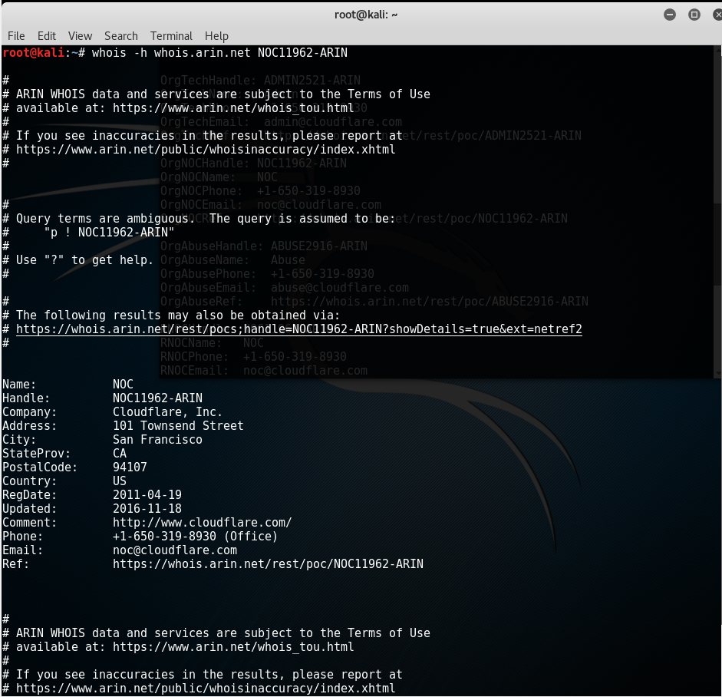  
  
#  
# Query terms are ambiguous. The query is assumed to be:  
# "p ! NOC11962-ARIN"  
#  
# Use "?" to get help.  
#  
  
#  
# The following results may also be obtained via:  
# https://whois.arin.net/rest/pocs;handle=NOC11962-ARIN?showDetails=true&ext=netref2  
#  
  
  
Name: NOC  
Handle: NOC11962-ARIN  
Company: Cloudflare, Inc.  
Address: 101 Townsend Street  
City: San Francisco  
StateProv: CA  
PostalCode: 94107  
Country: US  
RegDate: 2011-04-19  
Updated: 2016-11-18  
Comment: http://www.cloudflare.com/  
Phone: +1-650-319-8930 (Office)  
Email: noc@cloudflare.com  
Ref: https://whois.arin.net/rest/poc/NOC11962-ARIN  
  
  
  
#  
# ARIN WHOIS data and services are subject to the Terms of Use  
# available at: https://www.arin.net/whois_tou.html  
#  
# If you see inaccuracies in the results, please report at  
# https://www.arin.net/public/whoisinaccuracy/index.xhtml  
#  
  
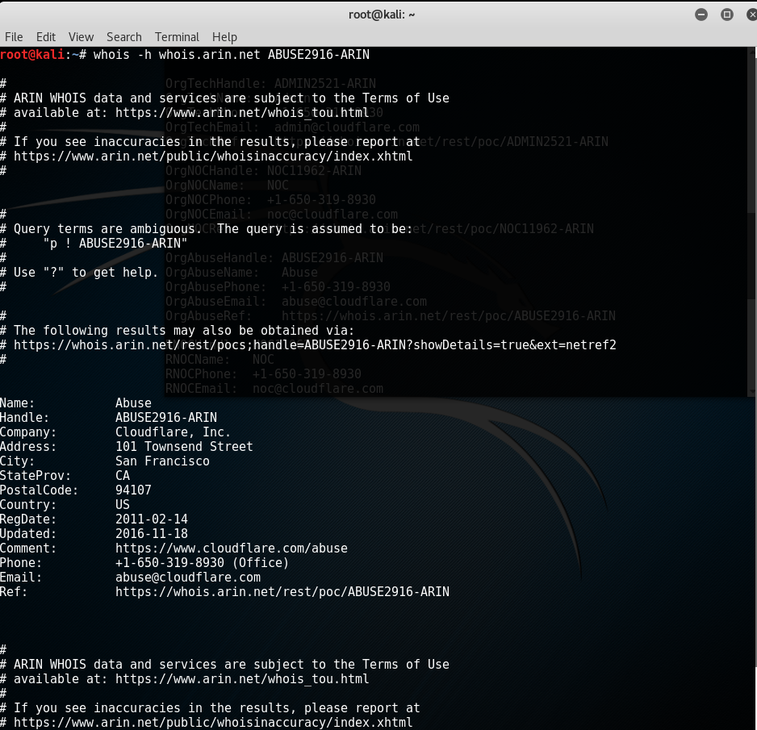

﻿

**root@kali**:**~**# whois -h whois.arin.net ABUSE2916-ARIN  
  
#  
# ARIN WHOIS data and services are subject to the Terms of Use  
# available at: https://www.arin.net/whois_tou.html  
#  
# If you see inaccuracies in the results, please report at  
# https://www.arin.net/public/whoisinaccuracy/index.xhtml  
#  
  
  
#  
# Query terms are ambiguous. The query is assumed to be:  
# "p ! ABUSE2916-ARIN"  
#  
# Use "?" to get help.  
#  
  
#  
# The following results may also be obtained via:  
# https://whois.arin.net/rest/pocs;handle=ABUSE2916-ARIN?showDetails=true&ext=netref2  
#  
  
  
Name: Abuse  
Handle: ABUSE2916-ARIN  
Company: Cloudflare, Inc.  
Address: 101 Townsend Street  
City: San Francisco  
StateProv: CA  
PostalCode: 94107  
Country: US  
RegDate: 2011-02-14  
Updated: 2016-11-18  
Comment: https://www.cloudflare.com/abuse  
Phone: +1-650-319-8930 (Office)  
Email: abuse@cloudflare.com  
Ref: https://whois.arin.net/rest/poc/ABUSE2916-ARIN  
  
  
  
#  
# ARIN WHOIS data and services are subject to the Terms of Use  
# available at: https://www.arin.net/whois_tou.html  
#  
# If you see inaccuracies in the results, please report at  
# https://www.arin.net/public/whoisinaccuracy/index.xhtml  
#

﻿

**﻿dnsrecon: This tool gave me a list of information in a domain and subdomain which could be points of attack. Also giving a list of Mail servers. Gave additional information on the cloudflare servers.**

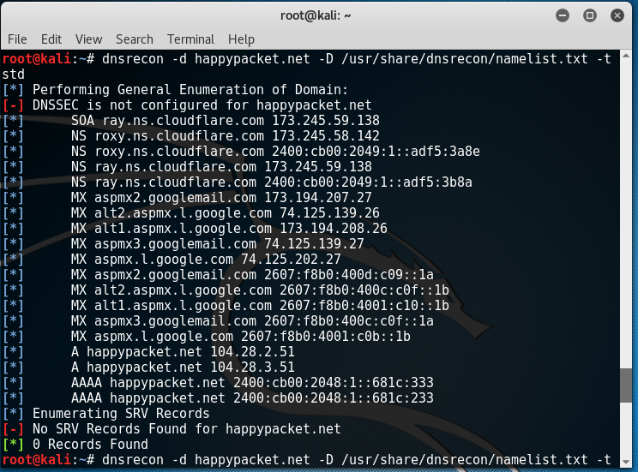

**root@kali**:**~**# dnsrecon -d happypacket.net -D /usr/share/dnsrecon/namelist.txt -t std  
**[*]** Performing General Enumeration of Domain:  
**[-]** DNSSEC is not configured for happypacket.net  
**[*]** SOA ray.ns.cloudflare.com 173.245.59.138  
**[*]** NS roxy.ns.cloudflare.com 173.245.58.142  
**[*]** NS roxy.ns.cloudflare.com 2400:cb00:2049:1::adf5:3a8e  
**[*]** NS ray.ns.cloudflare.com 173.245.59.138  
**[*]** NS ray.ns.cloudflare.com 2400:cb00:2049:1::adf5:3b8a  
**[*]** MX aspmx2.googlemail.com 173.194.207.27  
**[*]** MX alt2.aspmx.l.google.com 74.125.139.26  
**[*]** MX alt1.aspmx.l.google.com 173.194.208.26  
**[*]** MX aspmx3.googlemail.com 74.125.139.27  
**[*]** MX aspmx.l.google.com 74.125.202.27  
**[*]** MX aspmx2.googlemail.com 2607:f8b0:400d:c09::1a  
**[*]** MX alt2.aspmx.l.google.com 2607:f8b0:400c:c0f::1b  
**[*]** MX alt1.aspmx.l.google.com 2607:f8b0:4001:c10::1b  
**[*]** MX aspmx3.googlemail.com 2607:f8b0:400c:c0f::1a  
**[*]** MX aspmx.l.google.com 2607:f8b0:4001:c0b::1b  
**[*]** A happypacket.net 104.28.2.51  
**[*]** A happypacket.net 104.28.3.51  
**[*]** AAAA happypacket.net 2400:cb00:2048:1::681c:333  
**[*]** AAAA happypacket.net 2400:cb00:2048:1::681c:233  
**[*]** Enumerating SRV Records  
**[-]** No SRV Records Found for happypacket.net  
**[*]** 0 Records Found

﻿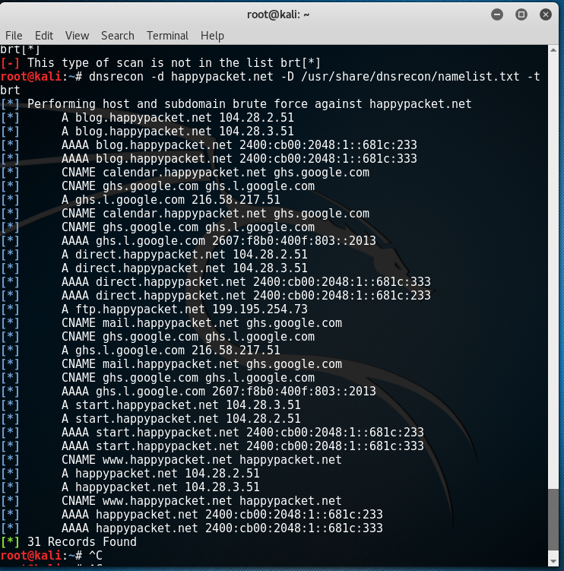

**root@kali**:**~**# dnsrecon -d happypacket.net -D /usr/share/dnsrecon/namelist.txt -t brt  
**[*]** Performing host and subdomain brute force against happypacket.net  
**[*]** A blog.happypacket.net 104.28.2.51  
**[*]** A blog.happypacket.net 104.28.3.51  
**[*]** AAAA blog.happypacket.net 2400:cb00:2048:1::681c:233  
**[*]** AAAA blog.happypacket.net 2400:cb00:2048:1::681c:333  
**[*]** CNAME calendar.happypacket.net ghs.google.com  
**[*]** CNAME ghs.google.com ghs.l.google.com  
**[*]** A ghs.l.google.com 216.58.217.51  
**[*]** CNAME calendar.happypacket.net ghs.google.com  
**[*]** CNAME ghs.google.com ghs.l.google.com  
**[*]** AAAA ghs.l.google.com 2607:f8b0:400f:803::2013  
**[*]** A direct.happypacket.net 104.28.2.51  
**[*]** A direct.happypacket.net 104.28.3.51  
**[*]** AAAA direct.happypacket.net 2400:cb00:2048:1::681c:333  
**[*]** AAAA direct.happypacket.net 2400:cb00:2048:1::681c:233  
**[*]** A ftp.happypacket.net 199.195.254.73  
**[*]** CNAME mail.happypacket.net ghs.google.com  
**[*]** CNAME ghs.google.com ghs.l.google.com  
**[*]** A ghs.l.google.com 216.58.217.51  
**[*]** CNAME mail.happypacket.net ghs.google.com  
**[*]** CNAME ghs.google.com ghs.l.google.com  
**[*]** AAAA ghs.l.google.com 2607:f8b0:400f:803::2013  
**[*]** A start.happypacket.net 104.28.3.51  
**[*]** A start.happypacket.net 104.28.2.51  
**[*]** AAAA start.happypacket.net 2400:cb00:2048:1::681c:233  
**[*]** AAAA start.happypacket.net 2400:cb00:2048:1::681c:333  
**[*]** CNAME www.happypacket.net happypacket.net  
**[*]** A happypacket.net 104.28.2.51  
**[*]** A happypacket.net 104.28.3.51  
**[*]** CNAME www.happypacket.net happypacket.net  
**[*]** AAAA happypacket.net 2400:cb00:2048:1::681c:233  
**[*]** AAAA happypacket.net 2400:cb00:2048:1::681c:333  
**[*]** 31 Records Found

**Maltego:**

**This was mainly what I found in other tests. I did pick up another email and contact that could be used.** [**baines.jacob@gmail.com**](mailto:baines.jacob@gmail.com)**. I was also able to find some additional IP Addresses, mail servers, ftp servers, and other possible contacts.**

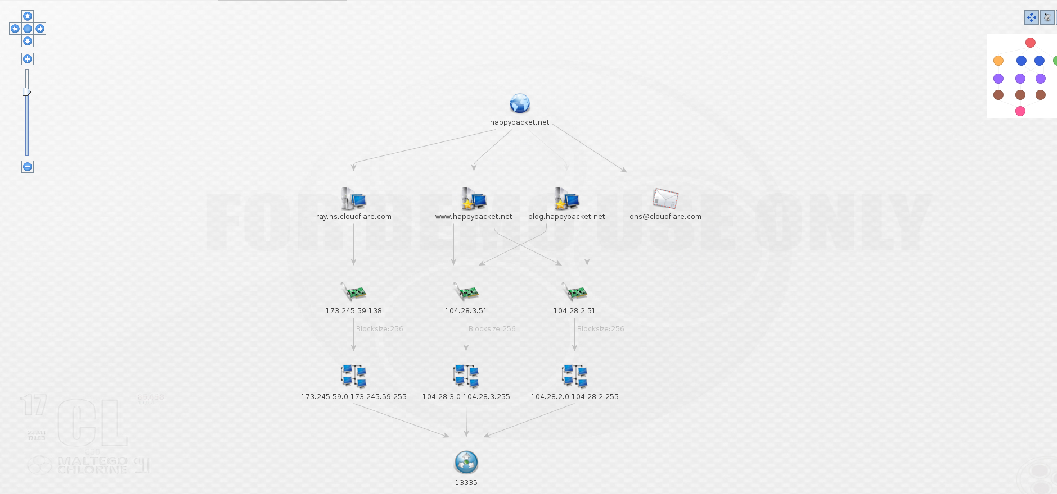  
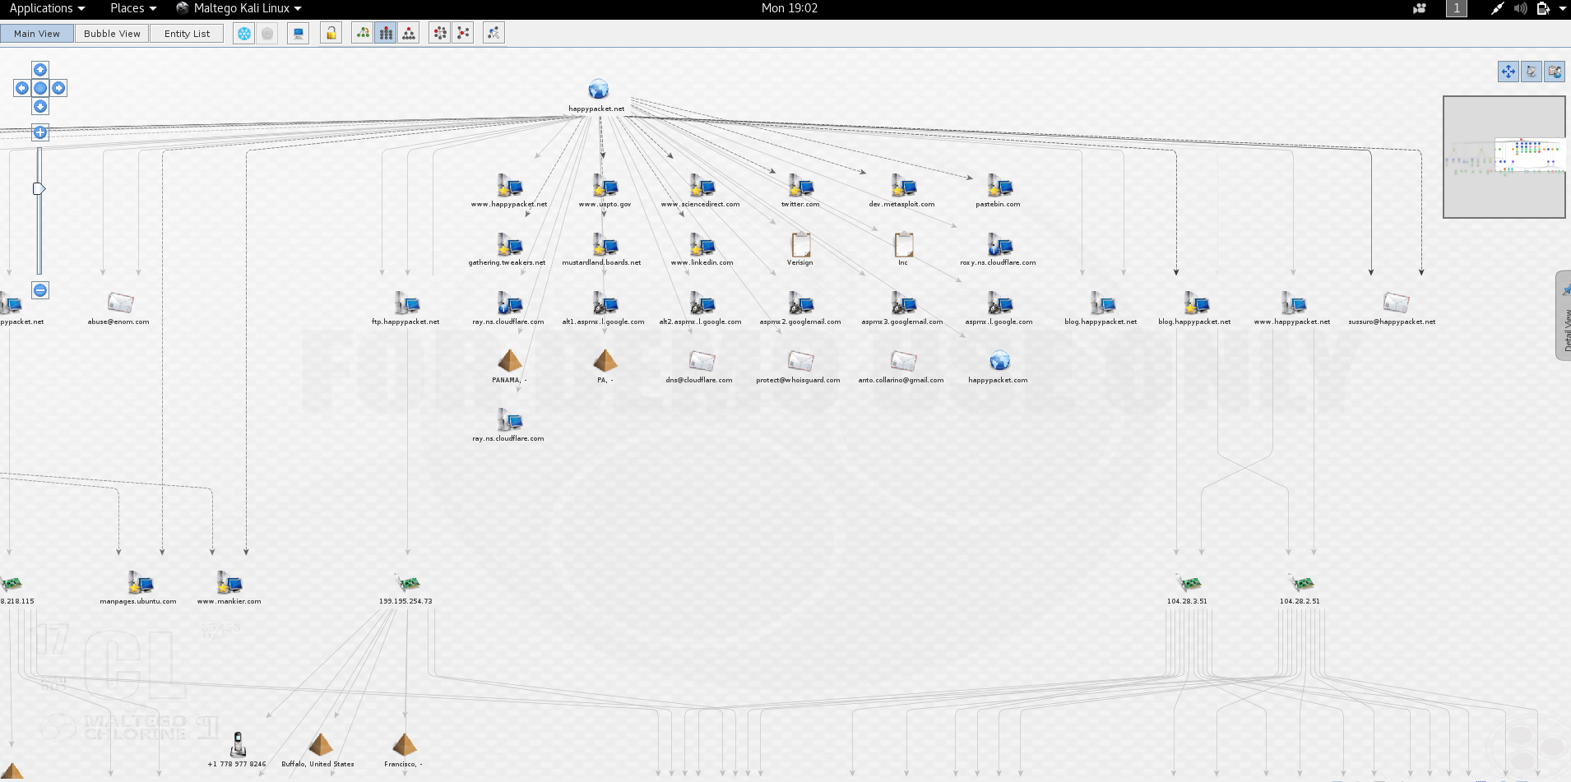

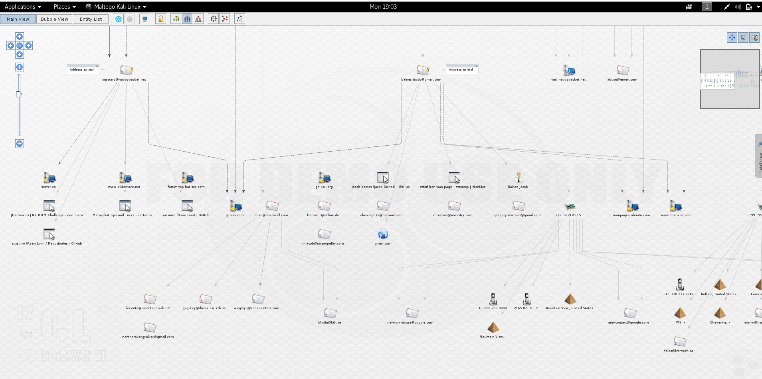

**DMITRY:**

**A great tool to use to get hostnames of servers and corresponding IP addresses for the subdomain which could be points of attack.**

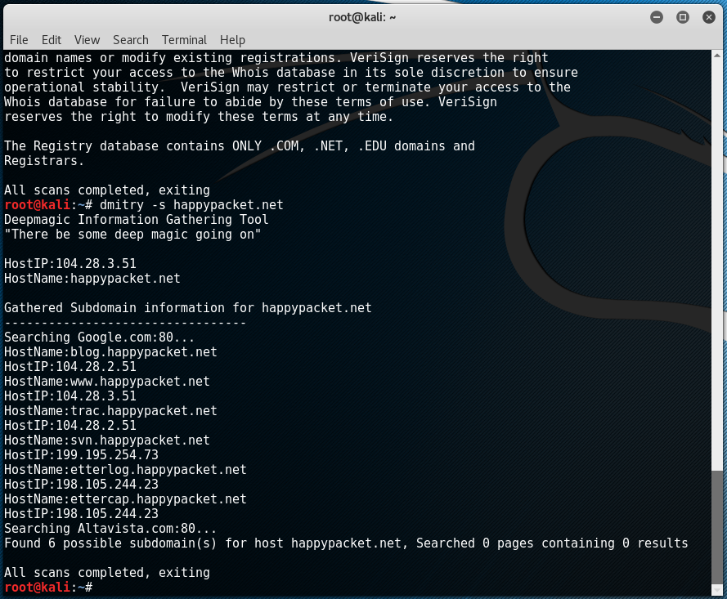

﻿

**root@kali**:**~**# dmitry -s happypacket.net  
Deepmagic Information Gathering Tool  
"There be some deep magic going on"  
  
HostIP:104.28.3.51  
HostName:happypacket.net  
  
Gathered Subdomain information for happypacket.net  
---------------------------------  
Searching Google.com:80...  
HostName:blog.happypacket.net  
HostIP:104.28.2.51  
HostName:www.happypacket.net  
HostIP:104.28.3.51  
HostName:trac.happypacket.net  
HostIP:104.28.2.51  
HostName:svn.happypacket.net  
HostIP:199.195.254.73  
HostName:etterlog.happypacket.net  
HostIP:198.105.244.23  
HostName:ettercap.happypacket.net  
HostIP:198.105.244.23  
Searching Altavista.com:80...  
Found 6 possible subdomain(s) for host happypacket.net, Searched 0 pages containing 0 results  
  
All scans completed, exiting

**Using waybackmachine:**

**Was very valuable for this assignment we couldn't pull up the actual site.**

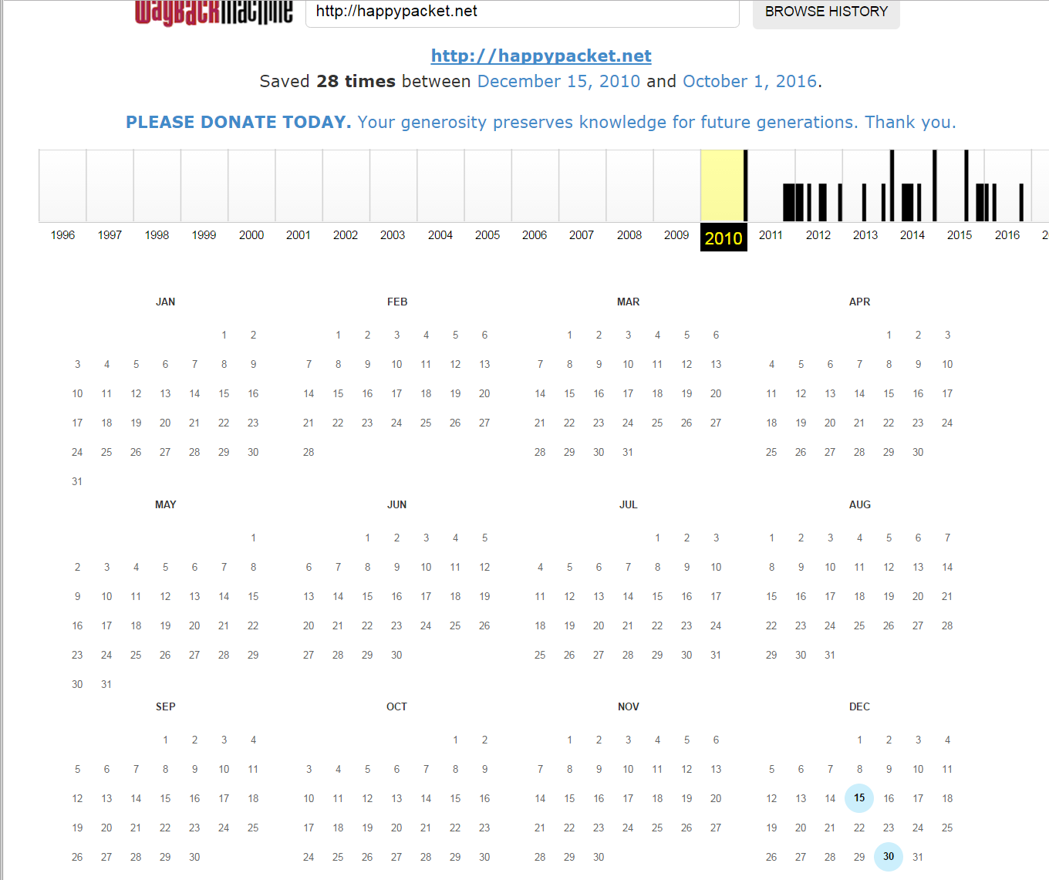

**I got the creater of this blog’s email(sussurro@happypacket.net) and Twitter handle(@sussurro). Going to that twitter page we can see that you(Ryan Linn) are susurro. The site was created on December 15th 2016 at 2pm.**

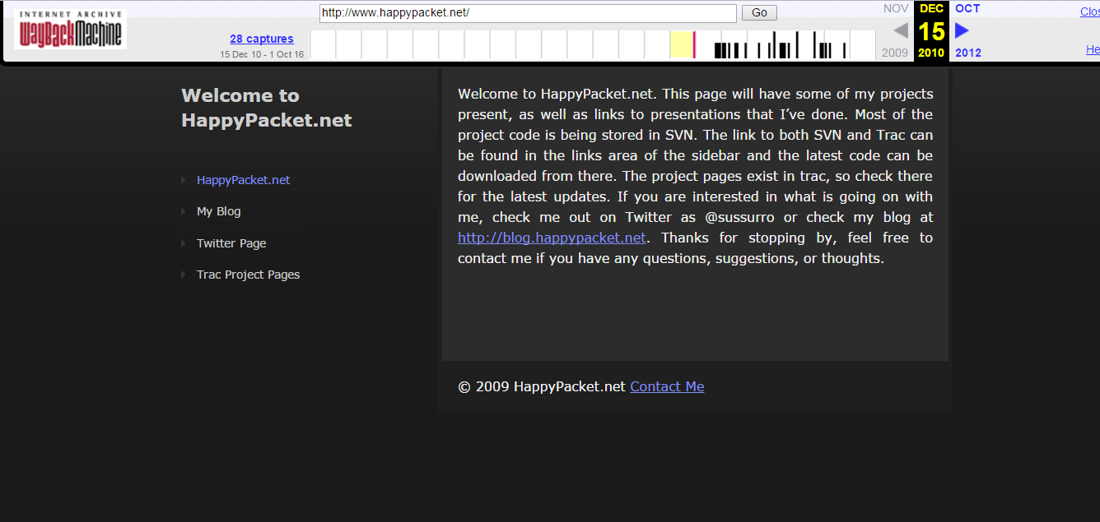

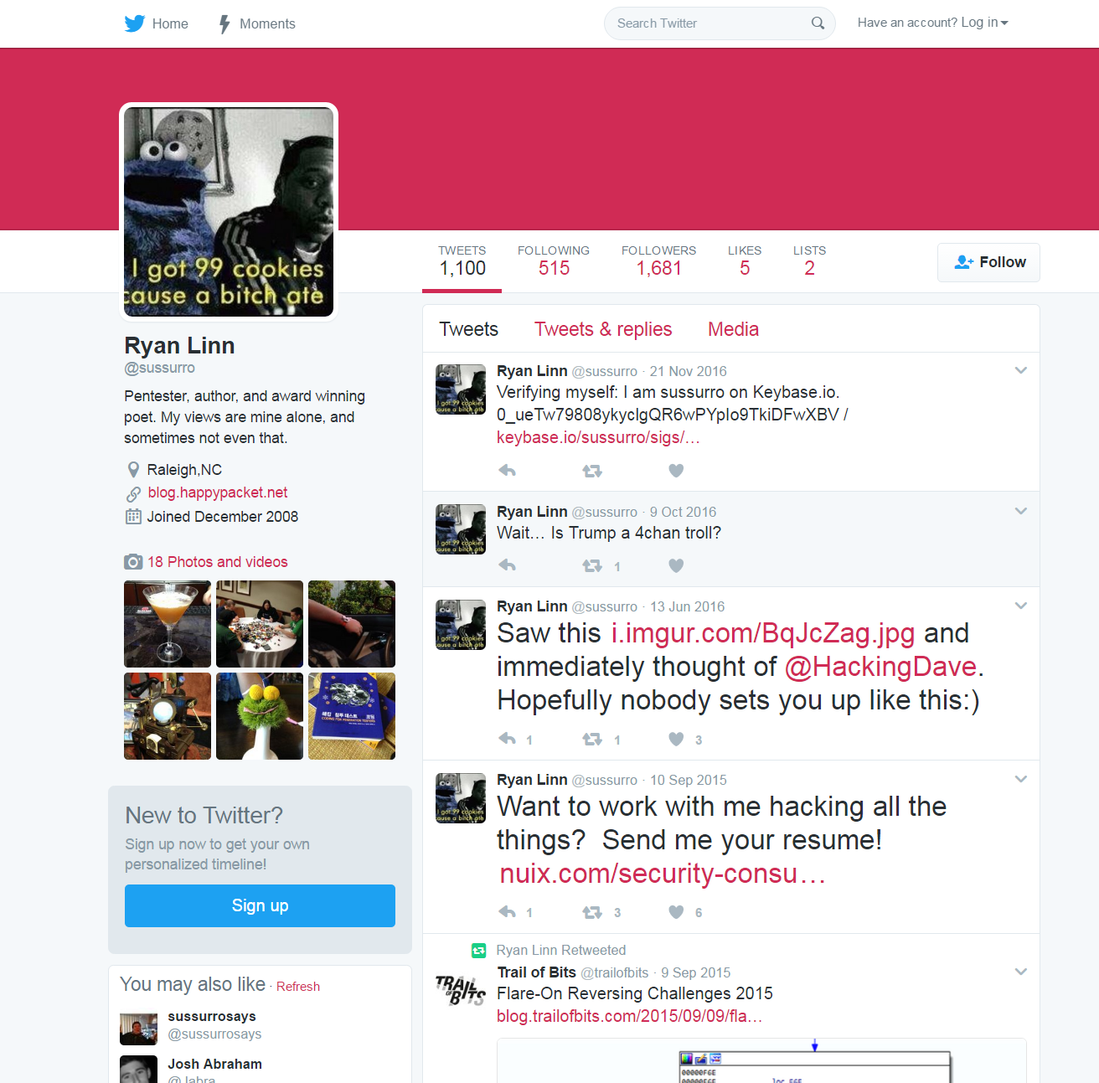

**From your twitter I can see that you work for nuix.com which also allowed me to stalk you further on linkedin, github, and Facebook. Twitter also lists your location too which is Raleigh, North Carolina, but this could not be very acriate and be a past location. We can also use websites like pipl.com to find other information which is how I found your facebook. I also found a phone number, address, middle name, age, and some possible people to contact. Also I really liked advancedbackgroundchecks.com(ABC) which got me an additional possible email address,** [**quema@gte.net**](mailto:quema@gte.net)**, phone numbers, addresses, and points of contact or other possible people to contact.**

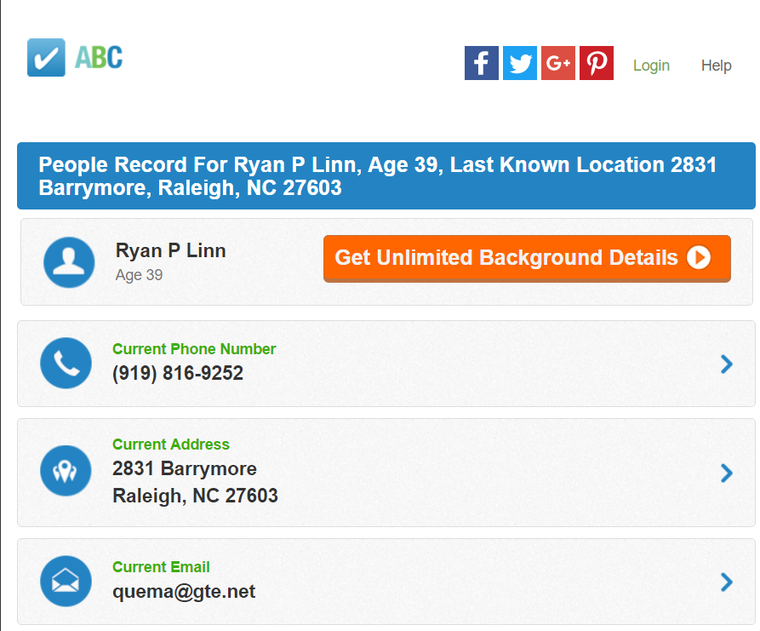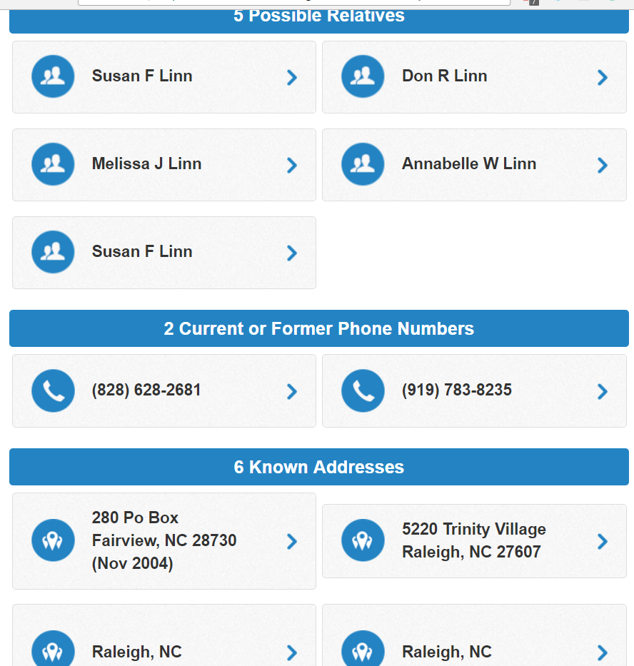

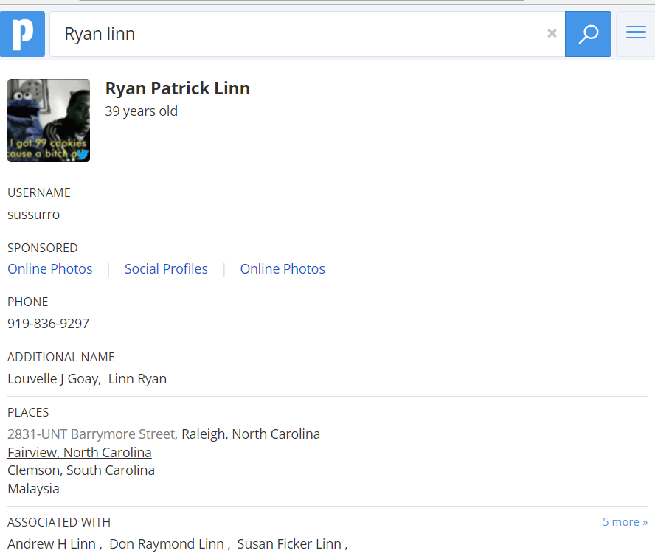

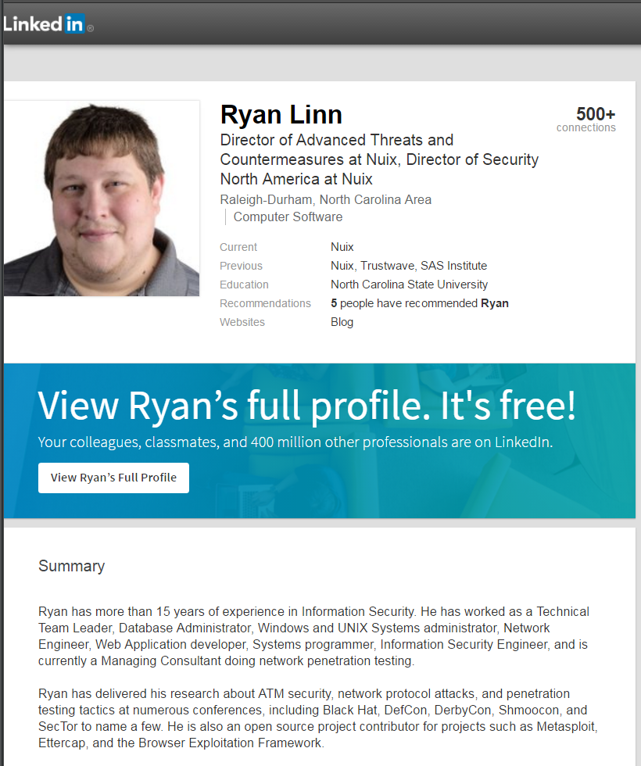

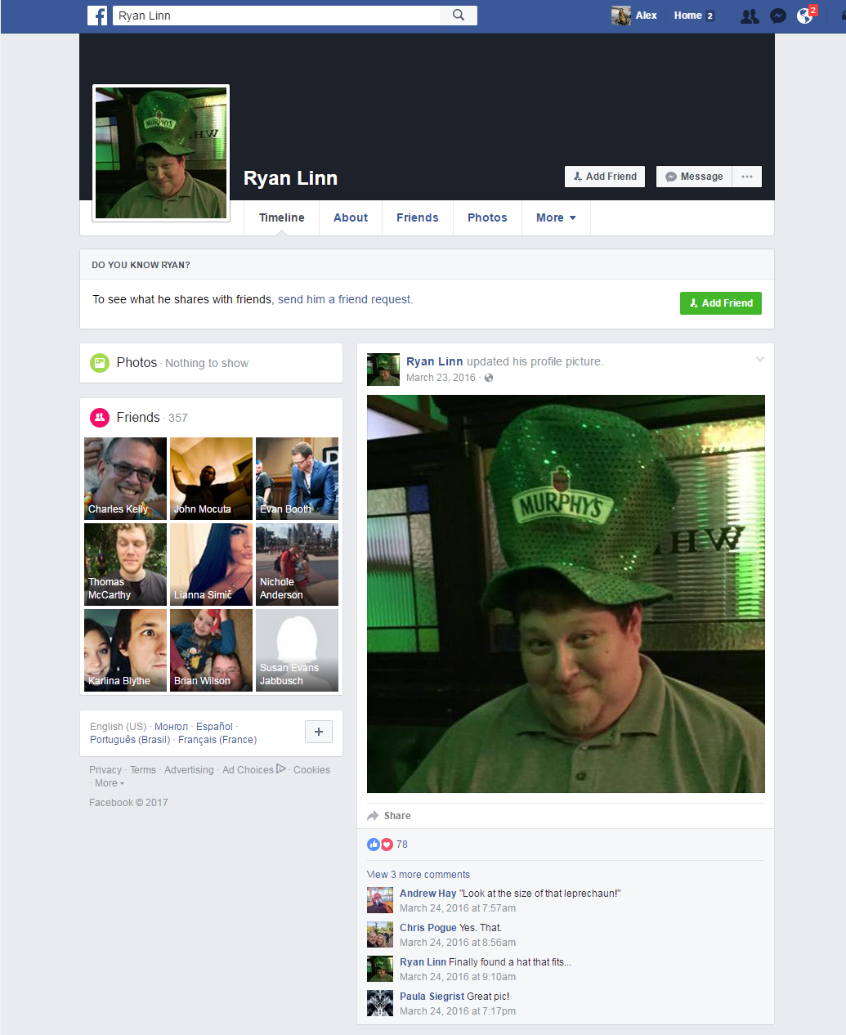

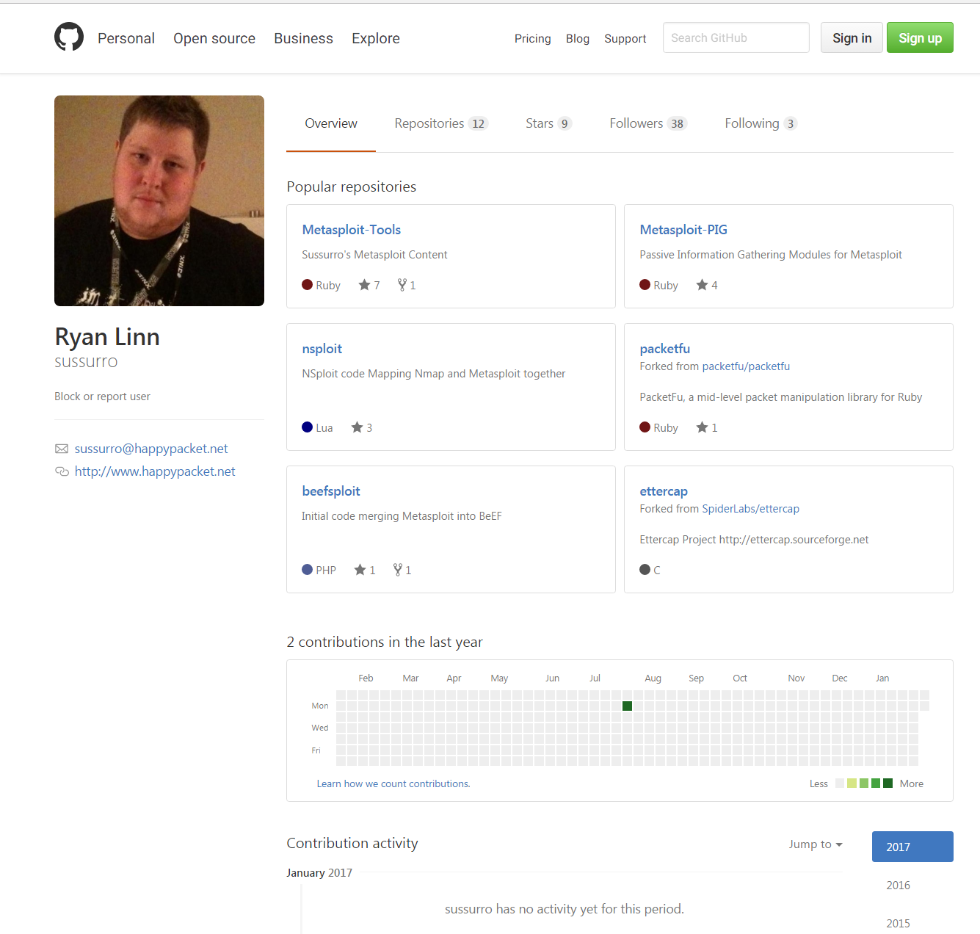

**Something happened on Oct 1st 2016 at 3:30pm, and now your site is unreachable. I suspect you took it down in anticipation for this class.**

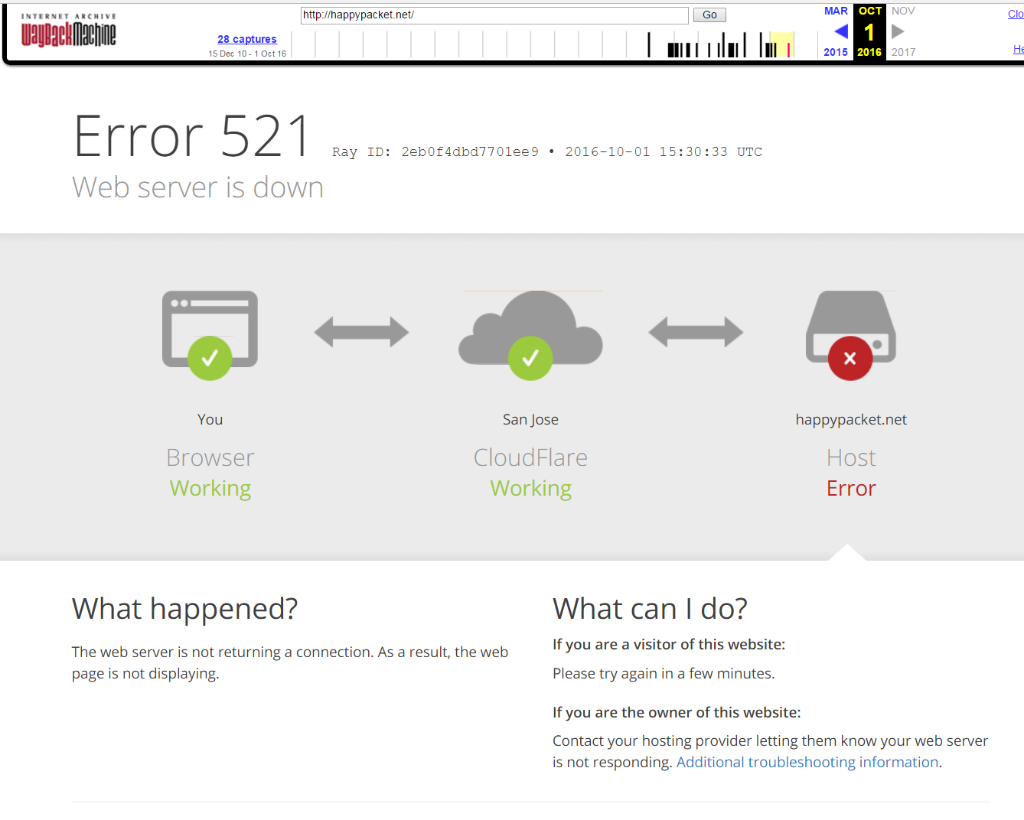

**Using checkusername.com:**

**I checked your username against several sites using checkusername.com. I know other people might have used your username, but it is still an indication of the different sites you might be registered for.**

